## PHIL 451W / 854: New Narratives in the History of Philosophy: Learning to Be a Thinking Thing in the 17th century

Library Research Workshop, Yolanda Koscielski: [ysk6@sfu.ca](mailto:ysk6@sfu.ca)

Liaison Librarian for Philosophy, Criminology, Psychology

May 18, 2022

## General Search Tips

* **Catalogue**: log in & use the Advanced Search for best results
* Boolean operators:
  + **AND** - connects concepts; reduces your search results because both terms must be present in your results
* (communism AND america)
  + **OR** - searches for related terms & synonyms, increases your search results because only one of either term needs to be present in your results
* (america OR “united states”)
* **Quotation marks** for a phrase; note that spelling variants might be excluded when you use these
  + “glorious revolution”
* **Asterisk** after the root of the word for alternative endings – some databases do this automatically
* child* picks up child, children, childhood, childish, childbeds, etc.

**General – Wayfinding at the SFU Library Website**

1. From the SFU Library website, find the list of databases by subject area: Philosophy.
   * How many databases are listed under Philosophy?
2. Find the list of databases that contain the content type, “primary sources”. How many of these are open access?
3. Find the guide, *Primary sources for the Humanities: Home* from the library website. Which tab on the left points to a page with search tips on finding primary sources?
4. Begin to place an interlibrary loan (without submitting it) via the library website. Note where you go to place this request.

**EEBO – Early English Books Online**

1. Access the database from the library website and run a search for *Madam de Maintenon* in the “anywhere” (default) search field. How many results do you have?
2. Try the same search for a third time, but this time by making use of the “Look up authors” link. This allows you to search the standardized name index of the database. Select the standardize name entry for *Madame de Maintenon* and run the search. How many search results did you find?

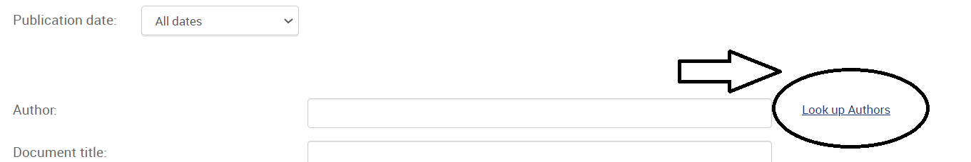

1. Search for *Madame de Maintenon* in the library catalogue. Select a search result for an item that is authored by her and then click on the author’s name in the linked author’s field (e.g., the text that says, [Maintenon, Madame de, 1635-1719](https://sfu-primo.hosted.exlibrisgroup.com/primo-explore/search?query=sub%2Cexact%2CMaintenon%2C%20Madame%20de%2C%201635-1719%2CAND&tab=default_tab&search_scope=default_scope&vid=SFUL&lang=en_US&mode=advanced&offset=20)). How many results do you receive?

**ECCO - Eighteenth Century Collections Online**

1. Access the database from the library website and run a search for Wollstonecraft in the authors search. How many results do you have?
2. Choose one the titles. Run a keyword search for “emotions” within your selected text. Is there a difference when you allow for spelling variations in your search, and when you do not?
3. Try a search using the “Topic Finder” search for a philosophical topic of your choosing, e.g., the problem of evil, justice, free will, etc. Is this a useful tool for discovering primary sources?

**SFU Library Collections**: try looking up *Princess of Bohemia* in LibrarySearch. What shows up under the search results category, SFU Library Digitized Collections?

**Bonus question**: if you have time, you can use Oxford Bibliographies Online (or one of the 3 aforementioned Philosophy encyclopedias) to see if there is an entry for your chosen topic and/or Philosopher of interest.